**Name: ___________________ Class: ­­­­­­­­­­­­­­­ __________**

Exercise 1: Look at the picture and letters. Write the word.

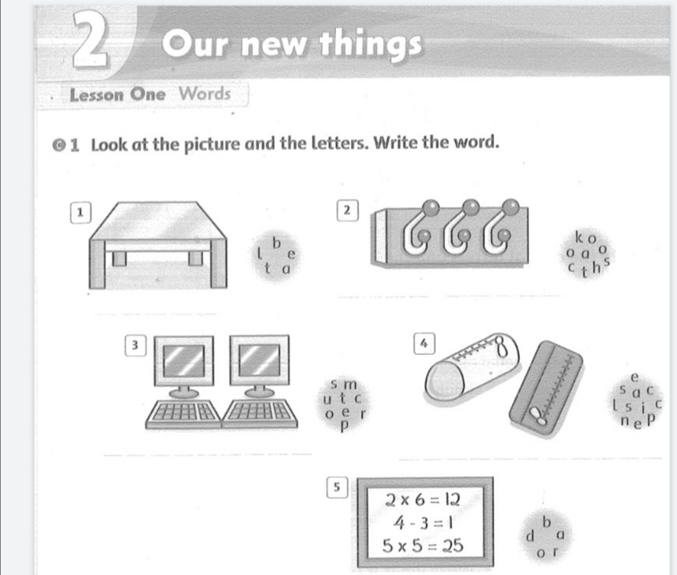

Exercise 2: Look at the picture again. Write.

1. There is a new table.
2. There are new …………………………..
3. There are new …………………………..
4. There are new ………………………….
5. There is a new …………………………….

Exercise 3. Find and circle the words.

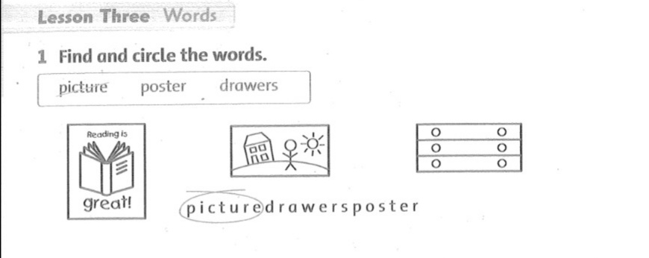

Exercise 4.

